|  |
| --- |
| Close-up image showing the leaf-sides of two oversized books side-by-side on a bookshelf, with additional books in soft focus background |
| Scramble Solutions  SSO-Server Management Guide |
| |  |  |  | | --- | --- | --- | | Known Directory | 7/29/24 | Management Guide | |

http://{your_server_path}/admin/

you will see below page.

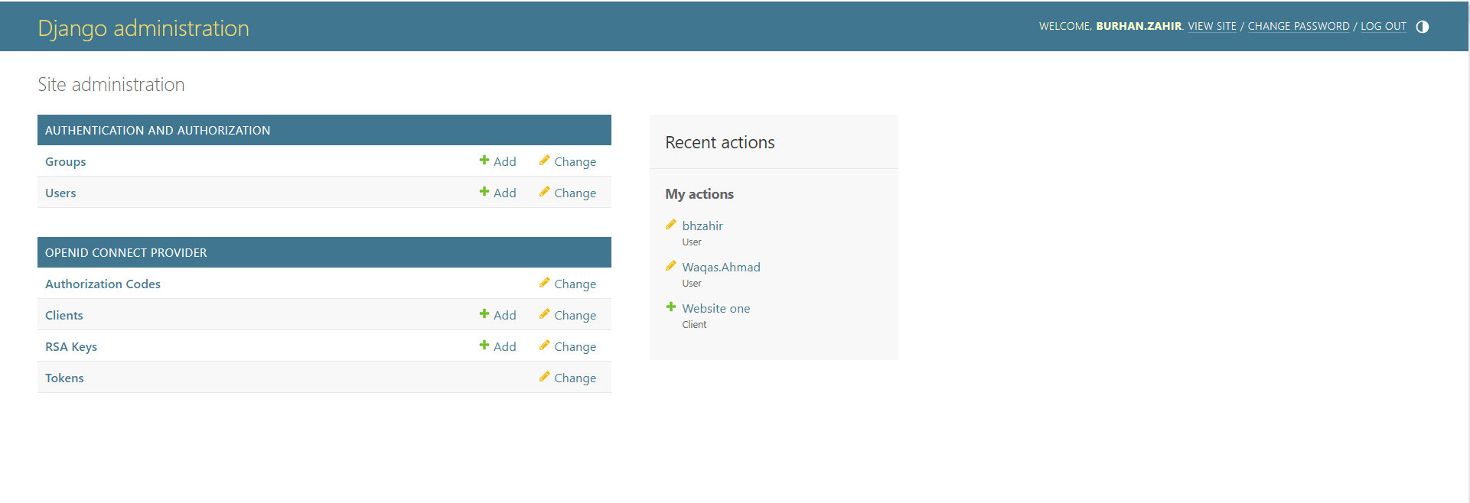

Click on Clients and then ADD CLIENT

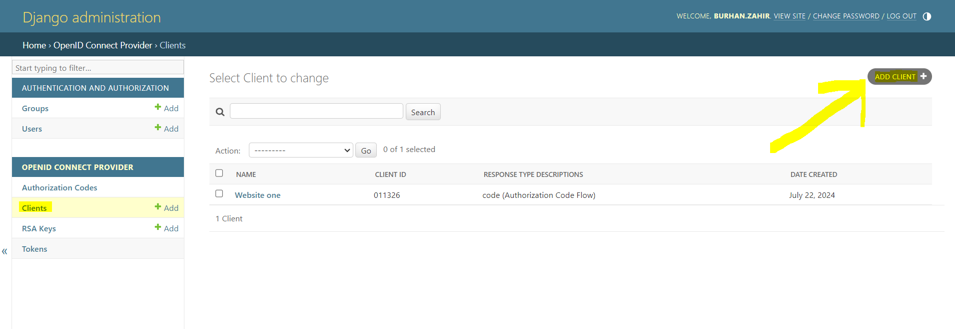

Fill out the form and save.

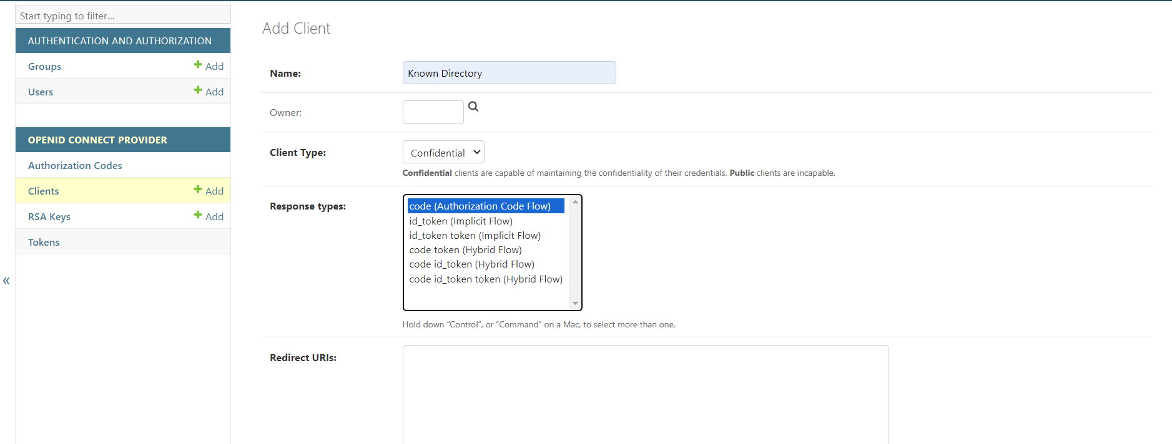

You will get Client Id and Client SECRET.

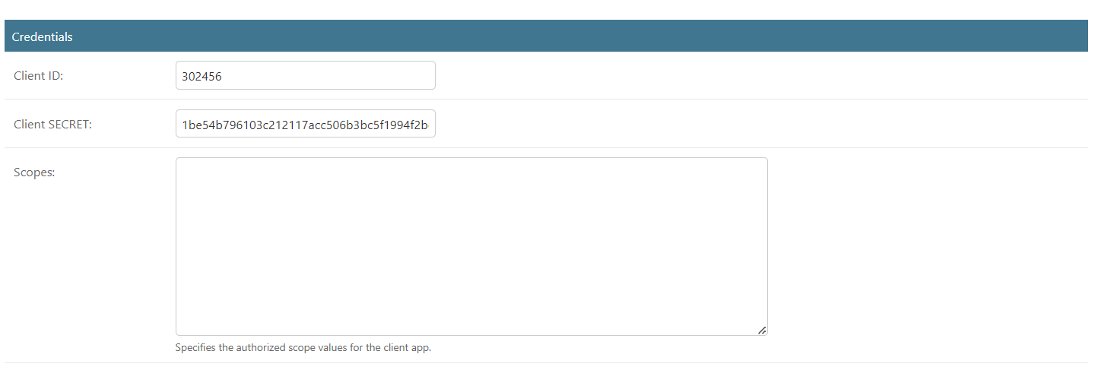

When a authorization request is generated by client website URL will look like this.

<http://auth-server.com:8000/authorize/?response_type=code&client_id=302456&redirect_uri=http%3A%2F%2Fauth-client.com%3A8081%2Fcallback%2F&scope=openid+email&state=JLocXilio6NWWTF090ehgpnAXlIgoa&code_challenge=IJD_dCHAAFEvkWDGmafkS7zofD-r6uVPHktNciZRWGk&code_challenge_method=S256>

And server will be like this to Authorize or to Decline.

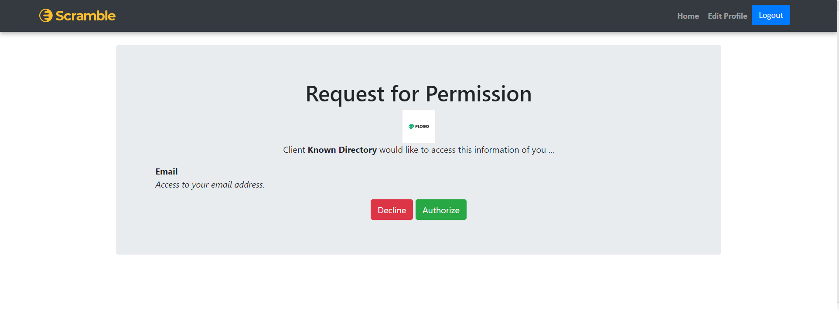

Logged in user can change his/her profile i.e.

